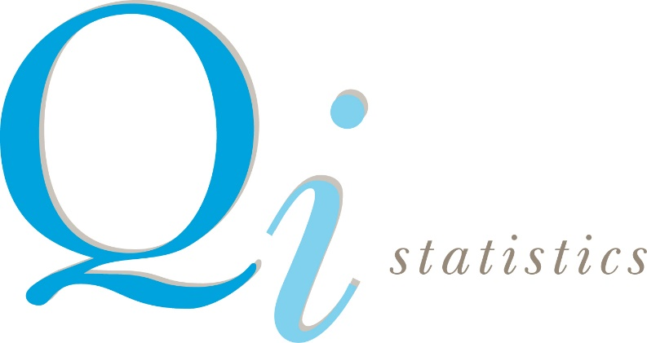
Upcoming courses 2022

Book directly on the website: https:www.qistatistics.co.uk

Time Zone | Training Course | Dates | Length | Price
Online  15:00 GMT | Hands on Sensory Statistics | 14, 17, 21, 24 March | 4 x ½ day modules | 1 module £395  2 modules £790  3 modules £1185  4 modules £1450
Online  07:30 BST | Hands on Analysis of Consumer Test Data using XLSTAT | 29, 30 March  5, 6 April | 4 x ½ day modules | 1 module £395  2 modules £790  3 modules £1185  4 modules £1450
Online  07:30 BST | Preference Mapping using XLSTAT | 11 April | 2 hour  webinar | £275
Online  07:30 BST | Preference Modelling using partial least squares in XLSTAT | 12 April | 2 hour  webinar | £275
Online  15:00 BST | Design of Experiments for Consumer Scientists | 3, 4 May | 2 ½ day modules | £790
Online  07:30 BST | Why and How of Discrimination Testing using EyeOpenR | 11 May | 2 hour  webinar | £275
Online  15:00 BST | Why and How of Discrimination Testing using EyeOpenR | 12 May | 2 hour webinar | £275
Online  07:30 BST | Discrimination Tests Using EyeOpenR: Beyond the Triangle and Tetrad | 18 May | 2 hour webinar | £275
Online  15:00 BST | Discrimination Tests Using EyeOpenR: Beyond the Triangle and Tetrad | 19 May | 2 hour webinar | £275
Online  15:00 BST | ANOVA Masterclass using XLSTAT | 1 June | 2 hour webinar | £275
Online  07:30 BST | Maxdiff / Best Worst Scaling –theory + practice (featuring XLSTAT and Qi Maxdiff Apps) | 28 June | 2 hour webinar | £275
Online  15:00 BST | Making Sense of Multivariate Data using XLSTAT | 5, 6, 12, 13 July | 4 ½ day modules | 1 module £395  2 modules £790  3 modules £1185  4 modules £1450
Online  15:00 | Hands on Analysis of Consumer Test Data using XLSTAT | 6, 8, 13, 15 September | 4 ½ day modules | 1 module £395  2 modules £790  3 modules £1185  4 modules £1450
Online  15:00 BST | Preference Mapping using XLSTAT | 20 September | 2 hour webinar | £275
Online  15:00 BST | Preference Modelling using Partial Least Squares in XLSTAT | 22 September | 2 hour webinar | £275
Online  07:30 BST | Hands on Sensory Statistics | 4, 5, 11, 12 October | 4 ½ day modules | 1 module £395  2 modules £790  3 modules £1185  4 modules £1450

All details, discounts and booking terms & conditions are on website.
Prices are also available in $ or Eu at live currency conversion rates.

